***ADVENTURE WORKS [Intermediate] Problem Statement: -***

The AdventureWorks sales excel workbook captures all the details of a fictitious, multinational manufacturing company called Adventure Works Cycles, including the details of customers, products, sales, territory etc. Load the dataset into PowerBI desktop and perform the following transformations to analyze and gain further insights of the company’s financial performance and profitability. Do all the necessary calculations and transformations using DAX functions and Power Query Editor.  
  
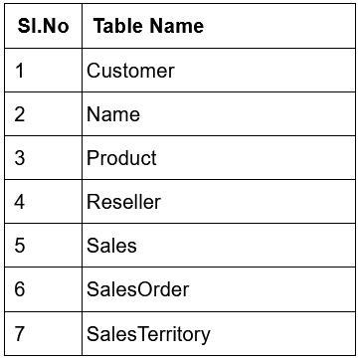

1. Load AdventureWorks Dataset, and check the Data Model.Convert the flat file into a star schema. (Hint: Join Sales table with Date table using appropriate common column).
2. Please see if we require any transformation of the data.
3. Create a new calculated column “Profit_cal_col” in the Sales table by subtracting Total product cost from Sales amount. Calculate “Profit_Que_Edi” On Power query editor. Compare the two values using Column visual with Date hierarchy.
4. Calculate Profit using appropriate DAX aggregate functions. Do the calculations using both SUM() Functions.
5. Convert Customer Name to uppercase letters using DAX function, UPPER().
6. Round the “Profit_cal_col” to two decimal values.

__________________________________________________________________________________

***Solution: -***

1. Loading the respective dataset namely, ‘AdventureWorks_Sale_2.xlsx’ via Excel Workbook under home or through power Query itself and loading a source, we get a look at all the tables available, we select all of the tables and load each of them into Power BI.  
     
   Now, we straight away are, required to Join Sales table with Date table. We can do this going via Model View and creating cardinality on the respective columns. Namely – Date[DateKey] and Sales[DueDateKey] tables[with their columns] (we could’ve joined the two tables into a separate table together but that wasn’t necessary step they only asked us to create a star schema which obviously means to create relationships or cardinality).  
     
   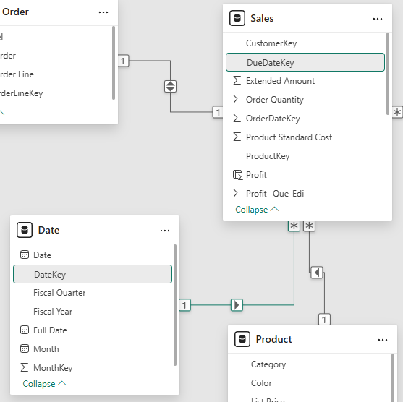 (here is the cardinality – 1 to Many, of Date with Sales table)
2. We are supposed to go to each and every table and check the datatype and perform necessary cleaning, remove any null values, see column quality in power query, promote headers, remove duplicates from the respective Primary Keys in the Table, remove Blank Rows, errors and duplicates, all cleanings were successfully completed.
3. To create a calculated column – ‘Profit_cal_col’, go to the column tools tab and under it click on New Column and hit the below code:  
     
     
   Now, to create a column named ‘Profit_Que_Edi’ in Power Query – Go to Transform Data and Select Sales Table and click on Add Columns and type in the column name as ‘Profit_Que_Edi’ and then type [Sales Amount] – [Total Product Cost] as follows:  
     
   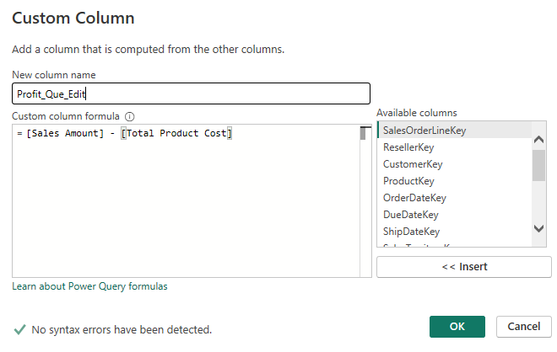  
     
   Now, to Visualise these two columns, one calculated and the other via power query, with Visualisation on a Table (Taking Date Hierarchy first and them both after) and on a Clustered Column Chart (Taking date Hierarchy on X-axis and taking the respective two column on the Y-axis – which we can drill down) as follows: -  
     
   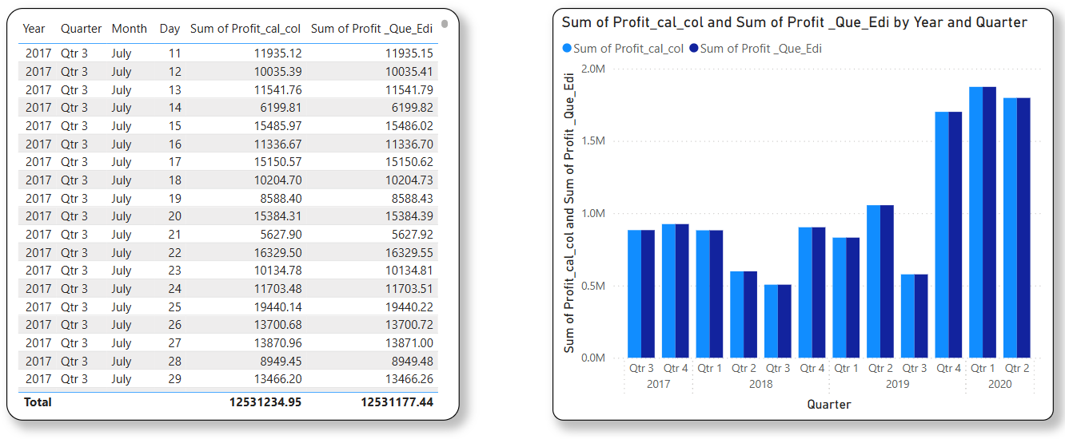
4. Now, we have to Calculate Profit using appropriate DAX aggregate functions both SUM() and SUMX() Functions [one does column wise aggregation and the other does row level aggregation - they mostly provide different results but in this case, the provided us with the same result.. which we will see]  
     
   Let’s take a Calculated Column named Profit and use SUM(), Function on it: -  
     
     
   And Now, let’s take another Calculated Column named Profit X and use SUMX(), Function on it: -  
     
     
   But however, both Sum and Sumx give same results: -  
   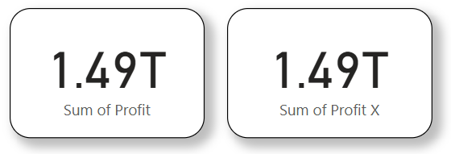  
     
   The results are same because, in this specific example, the data is structured in a way that the row-level aggregation and column-wise aggregation happen to produce the same result. This is not always the case, as the results may differ depending on the data structure and the calculation being performed.
5. Now, we select the Customers table and add a Column (Calculated Column) and write the DAX to provide us with the Upper Case Letters: -  
     
     
   And the results: -  
   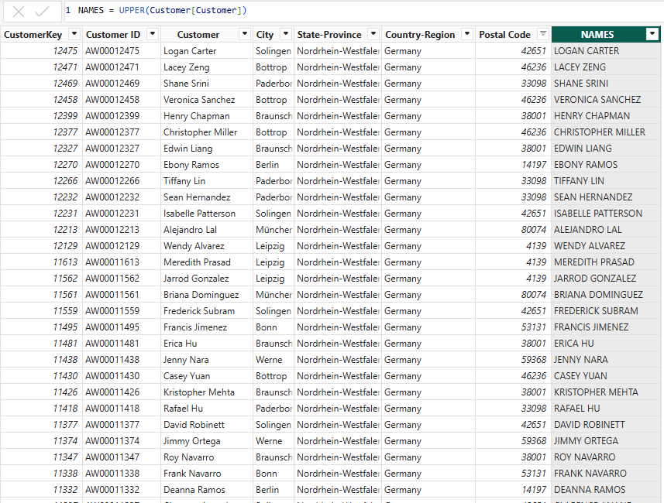
6. To round off, we cannot do it under column tools in report view, what we have to do is, we need to go to Power Query after hitting Transform data, then select the column ‘Profit_Que_Edi’ and then under Transform Tab first change it to decimal as follows:  
   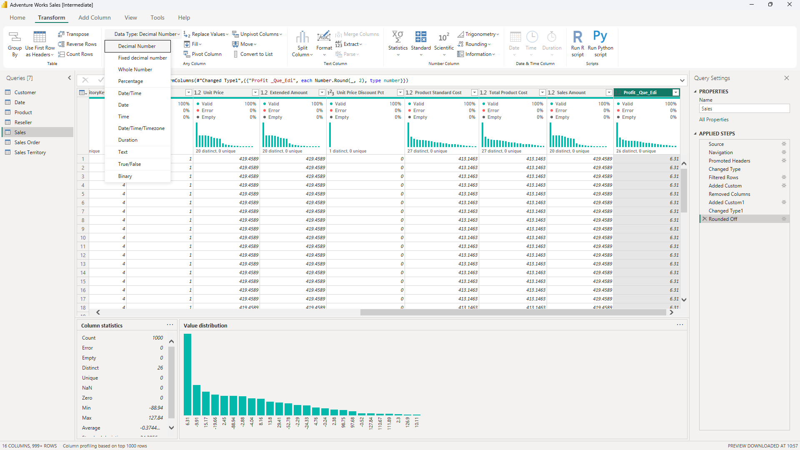  
     
   Then, in Rounding Column Section, there is an option with a drop down called ‘Rounding’, select ‘Rounding…’ and Select your decimal points, which is 2, and as the above image, it shows the respective column, rounded off to two decimal values.  
     
   P.S. – This Project was an exceptional Assignment where Implicit and Explicit calculated columns i.e., sum and sumx DAX gave same Values.  
     
     
   Project By – Bidarth Kr. Singh

*************************************************